Name: Richard Raymond J. Canda

C.Y.S.: BSCpE - 3A

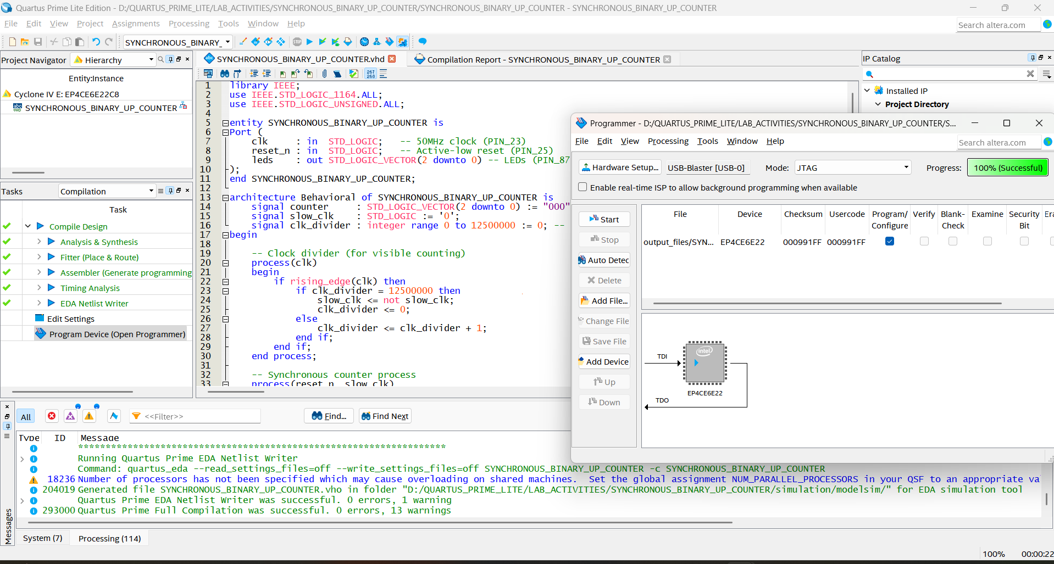

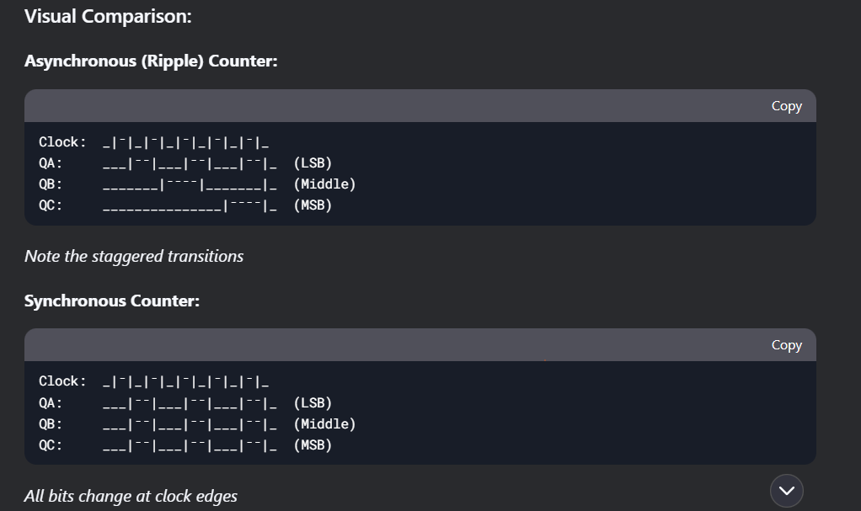

**SYNCHRONOUS BINARY UP COUNTER**

library IEEE;

use IEEE.STD_LOGIC_1164.ALL;

use IEEE.STD_LOGIC_UNSIGNED.ALL;

entity SYNCHRONOUS_BINARY_UP_COUNTER is

Port (

clk : in STD_LOGIC; -- 50MHz clock (PIN_23)

reset_n : in STD_LOGIC; -- Active-low reset (PIN_25)

leds : out STD_LOGIC_VECTOR(2 downto 0) -- LEDs (PIN_87,86,85)

);

end SYNCHRONOUS_BINARY_UP_COUNTER;

architecture Behavioral of SYNCHRONOUS_BINARY_UP_COUNTER is

signal counter : STD_LOGIC_VECTOR(2 downto 0) := "000";

signal slow_clk : STD_LOGIC := '0';

signal clk_divider : integer range 0 to 12500000 := 0; -- 2Hz @ 50MHz

begin

-- Clock divider (for visible counting)

process(clk)

begin

if rising_edge(clk) then

if clk_divider = 12500000 then

slow_clk <= not slow_clk;

clk_divider <= 0;

else

clk_divider <= clk_divider + 1;

end if;

end if;

end process;

-- Synchronous counter process

process(reset_n, slow_clk)

begin

if reset_n = '0' then -- Active-low reset

counter <= "000";

elsif rising_edge(slow_clk) then

counter <= counter + 1; -- All bits update simultaneously

end if;

end process;

-- LED outputs (active-high configuration)

leds <= counter;

end Behavioral;